Introduction Imagine the Possibilities: A Path to Employment Success
INTENT OF WORKSHOP
Parents of youth with significant disabilities may have a difficult time envisioning community-based competitive employment as part of their family member’s future. This may lead to low expectations for employment possibilities and unnecessary placement into segregated work settings. This workshop is intended to be a tool that advocates, educators, and service providers can use to provide accurate information to and help raise the expectations of families in the Bay Area. The goal is to show that work is possible for all people regardless of disability, to help address questions families may have, and to connect families with the resources they need to begin advocating for competitive employment for their family member.
TARGET AUDIENCE
The target audience for this presentation are family members and caregivers of youth and persons with significant disabilities. This group of families may be more likely to need help seeing that employment is an option for all people. The training is also useful as a professional training resource, helping those working with families to understand how to raise family expectations and have meaningful conversations about employment that lead to concrete action steps. Finally, youth and self-advocates should be encouraged to participate with their families. It is important to have people with disabilities have a strong voice in their futures, and to set goals that include real jobs for themselves.
CONTENT OVERVIEW
No single presentation can answer all the questions about employment or show all the available resources and supports available to people with disabilities. This session is meant to be an introduction to seeing employment as an option, and addresses the follow topics:
Opportunities for people with disabilities in today’s society
Challenges faced
Employment First and competitive employment (what are we trying to accomplish?)
Core employment concepts
Benefits of your family member working
The power of high expectations (and the impact of low expectations)
Helping youth create a vision statement
Preparing for employment success
Addressing your concerns
Social Security benefits overview
Action steps: Getting started
Presenters should view this session as “step 1” in a training and outreach effort to families. This information makes a nice lead in to more in-depth sessions on understanding and accessing specific services and supports, understanding Social Security benefits, and increasing self-determination of people with disabilities.
LOGISTICS AND RESPONSIBILITIES
This session was designed to be delivered in 2 hours, but can be expanded to 2.5 or 3 hours depending on activities, invited speakers, or additional content.
Parent training sessions work best when they are delivered face to face, but this session can also be done online via webinar.
Presenters are encouraged to be mindful of when and where you conduct the session. It often works best to conduct parent workshops in the evening and at “neutral” (not at a school or service provider office) location. Other considerations can include providing dinner or light snacks and refreshments and providing childcare.
Youth should be welcome to attend the sessions, but it is also OK if family members want to attend without their family member.
Presenters should feel free to customize the presentation to suit presentation styles and time constraints. However, it is important that any additions to the content be carefully vetted for accuracy.
Presenters are asked to have attendees fill out session evaluations. Please email copies of those evaluations to the California State Council on Developmental Disabilities at bayarea@scdd.ca.gov.
USE OF PRESENTER NOTES
A cadre of presenters will be trained on how to deliver this workshop and be provided with PowerPoint slides, presenter notes and the presentation worksheet. The presenter notes are not intended to be a script, and should not be used as such. The notes provide background for the presenter, and may offer strategies for delivering the material in the most effective way. If there is any information on the slides that you as a presenter do not understand, please feel free to contact Sean Roy from TransCen at sroy@transcen.org.
USE OF WORKSHEET
This parent workshop is designed to be highly interactive. A worksheet has been provided that will help generate discussion and get participants thinking about key concepts related to expectations, support, and employment. The worksheet corresponds with sections in the PowerPoint slides and asks participants to respond to 5 key questions:
- What do you hope adult life looks like for your family member?
- What is your family member’s greatest skill or attribute?
- What is your greatest concern when thinking about employment for your family member?
- What do you need to feel hopeful and energized about your family member’s employment future?
- Based on the information in this workshop, what are 3 action steps you will take to help start your family member on the path to employment success?
Presenters should encourage participants to write answers to these questions to these questions down on the worksheet as the presentation moves along. The last question is designed to have participants leave with some action steps in mind as they move forward. The back half of the worksheet can contain links and phone numbers to key local, state, and national resources.
A NOTE ABOUT TERMS USED
At various places throughout this presentation you will see employment referred to as “Community-based employment”, “Competitive employment”, “Integrated employment”, or “Paid, competitive employment”. These terms mean the same thing - jobs in the community, alongside people without disabilities, at minimum wage or higher. The use of multiple terms is an attempt to keep from using the same term too many times in the notes.
ROLE OF THE CALIFORNIA STATE COUNCIL ON DEVELOPMENTAL DISABILITIES
The State Council on Developmental Disabilities (SCDD) is established by state and federal law as an independent state agency to ensure that people with developmental disabilities and their families receive the services and supports they need. Through advocacy, capacity building and systemic change, SCDD works to achieve a consumer and family-based system of individualized services, supports, and other assistance. SCDD administers grants to community-based organizations to fund new and innovative program development projects. All projects are intended to implement the California State Strategic Plan objectives and improve services for Californians with developmental disabilities and their families. Grant cycle 43 funds projects of regional significance. SCDD’s Bay Area Regional Office is proud to partner with TransCen, funding this project to: 1. increase provider/professional staff capacity to effectively partner with families and self-advocates throughout the employment process and to 2. increase capacity to use customized employment methods. This aims to improve competitive integrated employment outcomes for individuals with IDD.
Slide 1
IMAGINE THE POSSIBILITIES: A PATH TO EMPLOYMENT SUCCESS
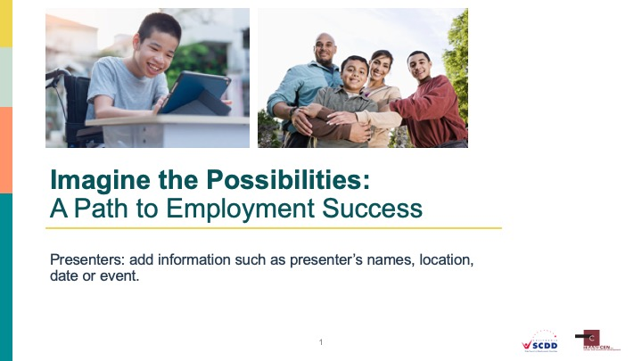
PRESENTER NOTES
This presentation slide should be customized to include name of presenters, date, location/event and co-sponsoring agencies. Provide attendees with the session worksheet and any additional resources at this time.
Presenters should welcome everyone, introduce themselves, go over logistics such as time session will end, time of break (if one is planned), and location of restrooms. The goal of the session is to provide families of youth and individuals with disabilities with accurate information about competitive employment in the community. We want to address concerns and answer questions, hopefully so attendees will begin feeling more comfortable with the prospect of exploring competitive employment for their family member. Presenters may wish to set the expectation for how questions will be handled during the session and speak briefly about the worksheet and its use during the workshop.
The introduction would also be an appropriate time to point out that the workshop is being brought to them with support from the California State Council on Developmental Disabilities. Finally, presenters should show the session evaluation form and ask that people turn forms in before leaving.

RELATED RESOURCE
Parent workshop session worksheet and any other resources can be handed out.

Slide 2
TRAIN THE TRAINER AGENDA
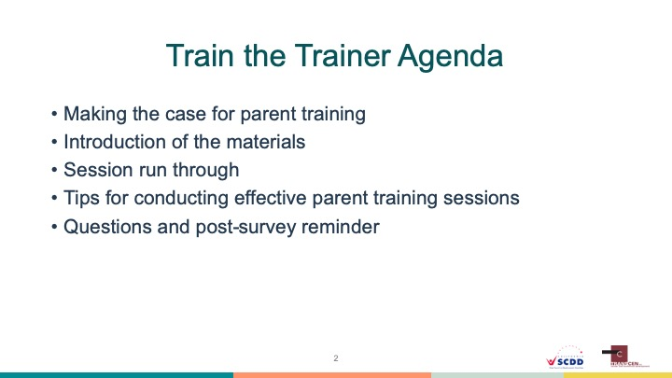

Slide 3
WHY CONDUCT PARENT TRAINING?
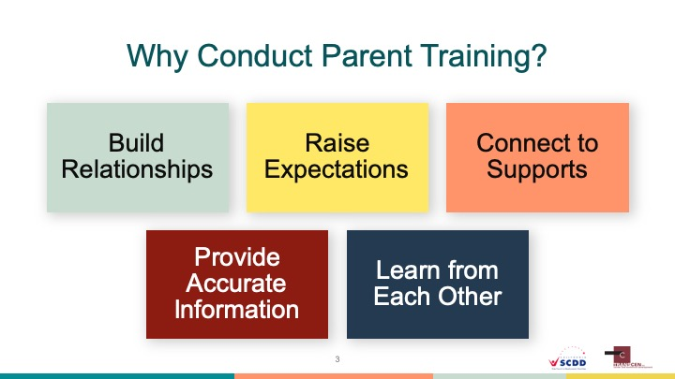

Slide 4
TRAINING MODULE INCLUDE
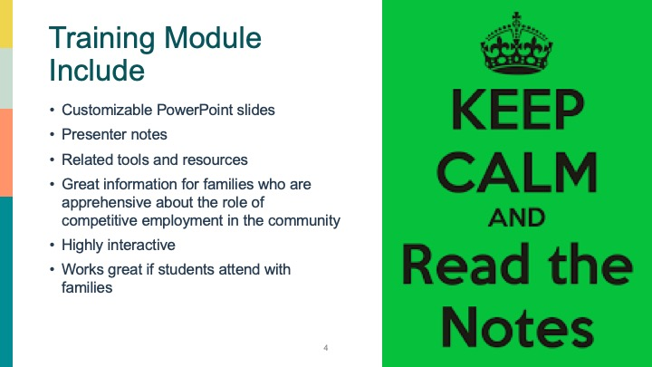

Slide 5
TODAY’S AGENDA
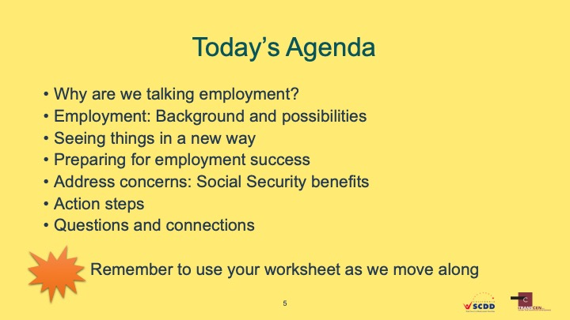
PRESENTER NOTES
It is suggested that presenters not spend too much time going over the agenda. It is intended as a quick look at some of the topics that will be covered.
Employment plays an important role in everyone’s lives, especially those with significant disabilities. Traditionally, people with disabilities have had limited opportunities for meaningful jobs in the community, but that is changing. What we want to do today is to discuss the reasons why employment is important, how things are changing for the better, and tools to help you see your family member as a person who can work. We will also discuss ways families can prepare youth to be successful on the job, because we know that families are the biggest influence on the lives of young people. We also understand that you may have questions and concerns, so we will also give you information on Social Security benefits and how work impacts them, and show you success stories from other families. We will be asking some key questions along the way and request that you use the worksheet provided to organize your thoughts and answers. Let’s get started.
Slide 6
WORKSHEET QUESTION 1
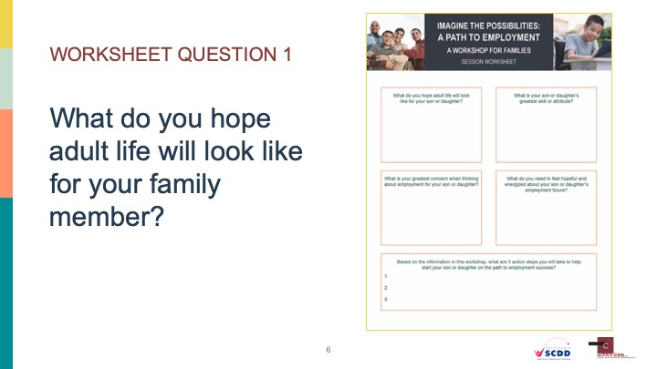
PRESENTER NOTES
The 5 key questions spread throughout the session are designed to get attendees thinking about hopes, dreams, skills, fears, and supports they may need. By addressing these types of topics we can better have an open dialogue about how to reach employment outcomes. This might be the first time attendees have thought in these specific terms, so it might be an emotional experience for them. Presenters will need to manage their time wisely through the sections where the 5 questions occur. Consider saying “I know we could talk all evening about hopes, dreams and fears for our family members. That’s what makes us parents. But let’s move onto the information to help answer some of your questions.”
What do you hope adult life will look like for your family member?
Instruct attendees to take a moment to write down in the corresponding box on the worksheet what they hope adult life will look like for their family member. If professionals are in attendance, they can answer thinking about a youth or individual with a disability they work with. Answers do not need to be specific to employment. Invite 2-3 attendees to share what they wrote. Point out that families have hopes and dreams for their youth with disabilities, and for many parents, those hopes include being a contributing, connected, employed member of their community.

Slide 7
TODAY, PEOPLE WITH DISABILITIES…
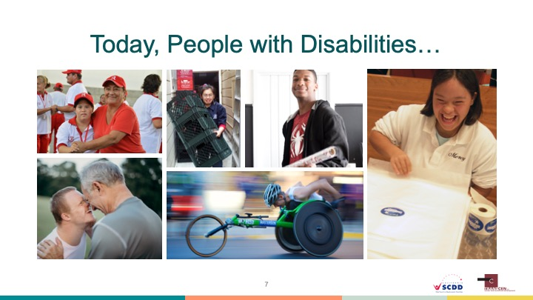
PRESENTER NOTES
This slide is included to show that people with disabilities are experiencing greater opportunities to be meaningfully employed, have friends and families, own homes, engage in hobbies of their choosing, and be respected members of their communities. This is setting the stage for high expectations through the rest of the presentation.
Today, people with all types of disabilities are working in their communities in a wide variety of jobs. Many students with significant disabilities have better opportunities to attend college programs or to further their education and obtain skills needed for employment. We see people living independently (with or without supports), owning homes, having families, and living the lives they envision for themselves. Families, self-advocates, disability advocates, and policy makers are working to break down the walls that once kept people with significant disabilities from being fully included into society. It is important for families to recognize this and to not put unnecessary barriers in the way of employment possibilities for their family member.

Slide 8
BUT THERE IS STILL WORK TO BE DONE…
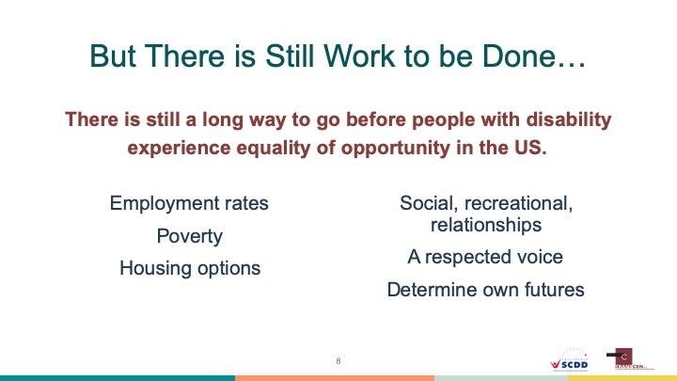
PRESENTER NOTES
To balance the information, presenters need to acknowledge that we still have work to do to reach equality of opportunity for people with disabilities. It is suggested that presenters not spend too much time on this slide. In general it is preferred to keep the tone of the session positive.
It would be unrealistic to report that people with significant disabilities have achieved fully equality of opportunity in this country. Employment rates for people with disabilities are significantly lower that of those without, many people are in danger of living at a poverty level, they have limited housing options in many areas, may experience a lack of social relationships or recreational outlets, and at times are ignored as potential contributors to communities. This inequality of opportunity ultimately leads to individuals who lack the ability to determine their own futures. This is what we are fighting to change and promoting meaningful employment for all is a good place to start.
Slide 9
EMPLOYMENT: SO MUCH IS POSSIBLE
PRESENTER NOTES
This slide indicates that the session is moving into a new topical section. Presenters can introduce it simply by saying “Employment for people with disabilities might be different from what you have heard or imagined. Let’s take some time to look at the concept of employment.” Should be a quick transition to the next content slide.
Now that we have talked about why we are here, let spend a little time discussing the concept of employment itself. It is important for us to be on the same page about what families should consider for their youth.

Slide 10
EMPLOYMENT: CORE CONCEPTS
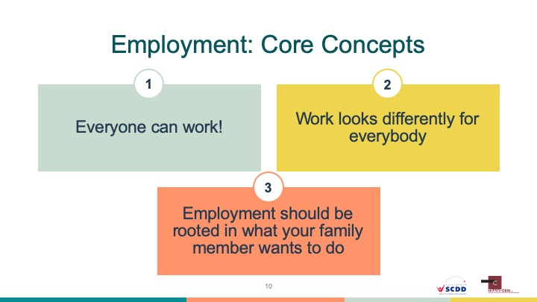
PRESENTER NOTES
These core concepts will help guide much of the conversation around employment for the workshop. They are intended to be simple, yet straight-forward statements that help frame thinking on the subject. Presenters should be prepared to answer questions regarding those with high support needs and their ability to actually work. One strategy is to say that “work” looks different for everyone and that later in the session we will discuss how to view success. This is also a good place to continue bring the conversation back to self-advocacy, and helping young people have a voice in where they work and what supports they receive.
Before we talk about exactly what we mean by “employment” it is important that we understand 3 key concepts. Discussing these can hopefully get us past some common misunderstandings about disability employment.
Everyone can work!: Disability can impact a person in a variety of ways. For some, the disability has a significant impact on communication, mobility, or cognitive functioning. Some families may believe that their family member is too disabled to work. This tends not to be true. People with all types of disabilities continue to be very successful in the workplace. This is possible with the right supports and with families who have high expectations. Later in the session we will see some remarkable success stories that show great things are possible (if a video or panel is being used).
Work looks differently for everybody: Families may be concerned that their family member might not be able to work a 40 hour work week or in fast-paced environments doing difficult tasks. This may be true, so the secret is to start small. For some youth working 5 or 10 hours a week is a great start. Granted, not all jobs might be appropriate right away, but there are effective employment programs that can help “customize” jobs for all skill levels and interests. The point is that employment success should be measured on an individual basis, not against what others do.
Employment should be rooted in what your family member wants to do: As parents we want our kids to find happiness and fulfillment is all areas of life. Unfortunately, people with significant disabilities too often have little say in what happens in their life. Families should see their role as helping youth set a vision for themselves about what life will look like and help support them in reaching that goal. This is often referred to as “self-advocacy”, or the ability people have to direct what is happening to them.

Slide 11
“EMPLOYMENT FIRST”
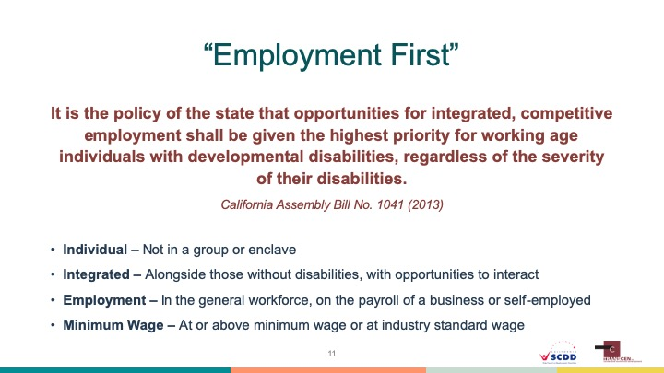
PRESENTER NOTES
Presenters can use this slide to 1) introduce the concept of Employment First, and 2) discuss what we mean by integrated employment (also referred to here are community-based employment, competitive employment, etc.) by using the components of employment first. It will be helpful to mention that Employment First is not in itself a program, rather a nationwide movement promoting employment as the first and preferred option for all people with disabilities. Due to the wide array of misinformation associated with Employment First, presenters may want supporting resources handy to help answer questions.
In the early 2000s advocates and policy makers began discussing an employment philosophy for people with significant disabilities. They called it Employment First. It was envisioned to counteract the overuse of sheltered work for people who could work in the community. Employment First simply advocates for competitive employment in the community being the first option that is considered for employment (not automatically going into sheltered work of day programs). The majority of states now have some sort of Employment First policy or language that guides the way employment services are delivered.
The core components of Employment First help us define what we mean by “employment” in this session. Competitive Integrated Employment are jobs that:
Are gained and done on an individual basis. This means that the job is not done as part of a segregated group or as part of an enclave. For example, a groups of people with disabilities bussed to locations to do work is not an individual job.
Is integrated - where the employee with a disability works alongside those without disabilities and is given opportunities to fully interact with co-workers. A person who is kept away from co-workers and not given an opportunity to be part of the work culture is not in an integrated job.
Is in the general workforce - where the job actually exists or has been customized for the job seeker, and the employee is on the payroll of the business or is self-employed. A person who works, but is not recognized as having an official position within the business, and who gets paid through a service provider rather than the business itself, is not part of the general workforce.
Pays minimum wage or the prevailing wage for jobs in that sector. A person who makes below minimum wage (referred to as sub-minimum wage) or who gets paid drastically less than those without disabilities doing the same job, does not have a fully integrated and competitive job.
Slide 12
WHY SHOULD YOUR FAMILY MEMBER WORK?
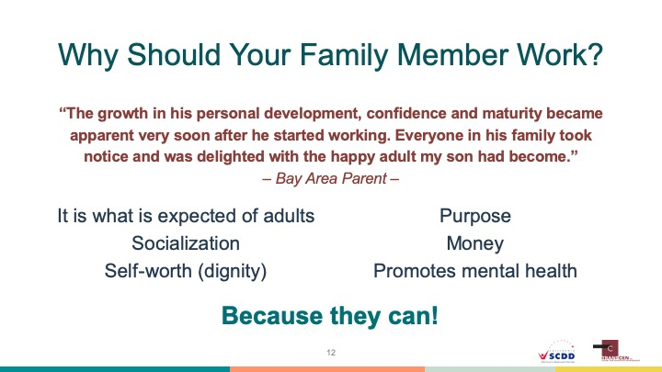
PRESENTER NOTES
We have attempted to lay the foundation for understanding the value of employment and how society is moving towards greater employment opportunities for people with disabilities. But it is also important to show the benefits of employment to the individual - the family members of the people attending the workshop. Presenters can ask attendees to quickly think about the benefits employment brings to them. Those might include money for basic needs and recreation, the opportunity to spend time doing something productive, a feeling of contributing to family and community, or the opportunity for additional social connections. People with disabilities experience those same benefits when they are employed in real jobs getting paid real wages. In addition, working promotes mental health. Presenters might ask if there are other benefits not listed on the slide. Ultimately, youth should be expected to have jobs as adults because they can, and that is what is expected of people of a certain age. There is no reason to expect less from a person just because they have a disability.

Slide 13
THE NEW REALITY
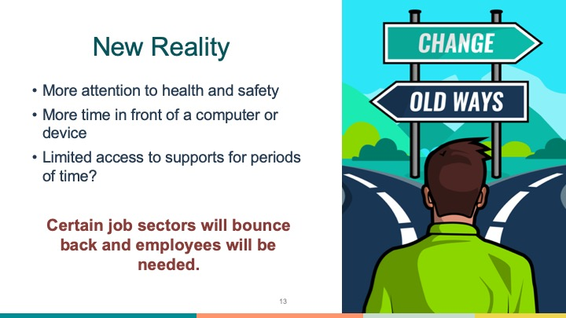
PRESENTER NOTES
The Covid-19 pandemic has significantly impacted businesses and the availability of employment supports. However, it is important not to think that this situation is permanent. There will come a time where life gets back to normal and employers will once again need employees. This slide is intended to acknowledge that things have changed, but that the future is still bright for people with disabilities in employment.
There is no doubt that the Covid-19 pandemic has impacted the number of jobs available and how employment supports for people with disabilities are provided. Many people have found themselves without paid work or community supports as a result. However, there will be a time where communities will open back up and supports will be reestablished. But things may never get back to what we considered “normal”.
Everywhere in our society there will be an increased emphasis on health and safety, both for employees and in the types of jobs that will be needed. Sanitizing will become a priority and starts and stops may be more frequent. Certain job supports may be done virtually, which will increase time interacting with screens and technology. It may take a while for employment supports to ramp up to previous levels, especially in more rural areas. The hopeful outlook is that eventually businesses will reopen and will need employees. People with disabilities are not automatically excluded from these opportunities. Families should continue to help their loved one prepare so they can be ready when opportunities arise.

Slide 14
SEEING YOUR FAMILY MEMBER IN A NEW WAY
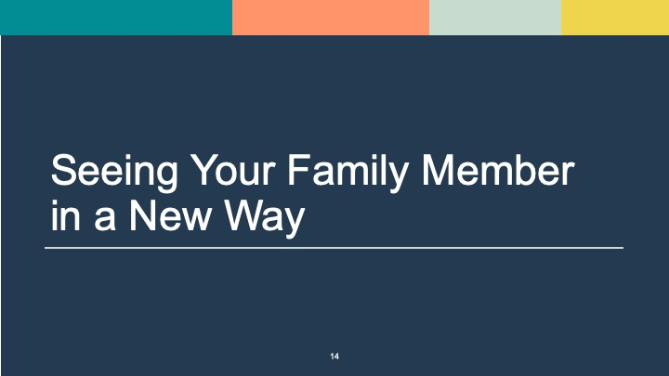
PRESENTER NOTES
This is another section break slide indicating that the focus will now shift to how families can balance having high expectations with the realities of the support needs faced by their family member with a disability. We discuss the importance of having high expectations for employment success and offer tools and stories to help the process. This is a transition slide, so don’t take much time on it.
Now that we are on the same page in regards to what we mean by “employment”, let’s shift the focus to high expectations and beginning to see your family member as a member of the workforce.

Slide 15
HOW DO WE DEFINE EXPECTATIONS?
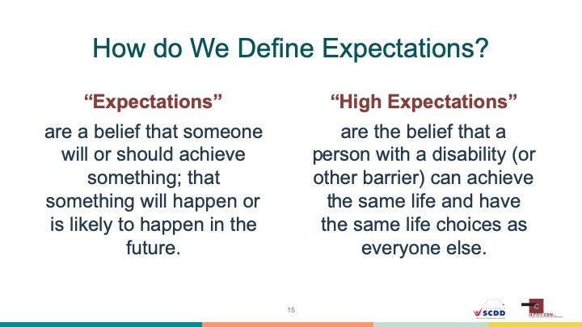
PRESENTER NOTES
One of the main goals of this workshop is to help families shift their expectations away from sheltered work or day programs as being the only option, and towards the possibility of their family member being employed in the community. The disability field is beginning to recognize the impact family (and professional) expectations have on youth employment and education outcomes. Therefore it is helpful to spend some time helping families see that what they may have envisioned for their youth was in fact not the most they could potentially accomplish. Read the definitions on the slide to attendees.
Now we would like to spend a little time talking about expectations - specifically where low expectations come from and how important high expectations are. As eluded to in the definitions on the slide, expectations are just one person’s or a group of people’s quick assumption about what another person or group of people can accomplish. People do this all of the time, often subconsciously, as a way to help order their world. Think about some of your own quick assumptions. For example, what do you assume when you see an elderly person driving or a short person playing basketball? Do you make quick assumptions about how well they can do the task at hand?
Unfortunately, people with disabilities are subject to other people’s negative assumptions all of the time. People may assume that a person in a wheelchair cannot be a construction worker or a person with autism cannot hold a position of high responsibility in a company. These assumptions are false, but we can get trapped by them nonetheless. We are learning more and more about the power of expectations and how negative messages impact the decisions families make for their family member with a disability. Helping families understand the power of expectations can also help them examine the expectations they have for employment.

Slide 16
WHERE DO LOW EXPECTATIONS COME FROM?
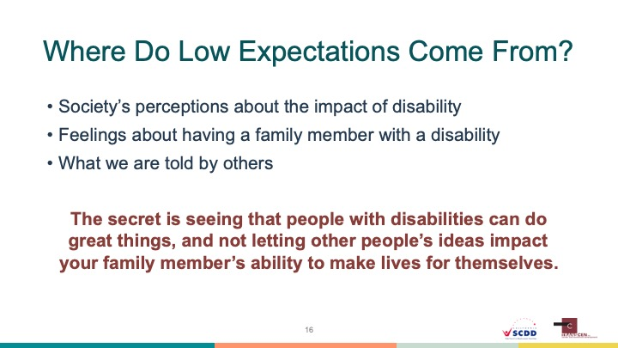
PRESENTER NOTES
Let’s turn our focus to families of youth with disabilities and examine how they might gradually acquire a lowered expectation for what their family member will accomplish in various aspects of life. Early on families receive negative messages about their loved one having a disability. A well-meaning doctor might suggest a newborn will never be able to do certain things. A child might be placed in a separate education setting based on their disability - highlighting to the family that they are different from other children. Or friends and family may try to be helpful by saying there are great programs for “those type of people”. Being bombarded with messages about “can’t” or “won’t”, it is no wonder families tend to modify their expectations downward. The first step to combat this is for families to recognize the skills and talents their family members possess, and to begin setting a vision based on those and not what other people think or assume.

Slide 17
THE IMPORTANCE OF HAVING HIGH EXPECTATIONS
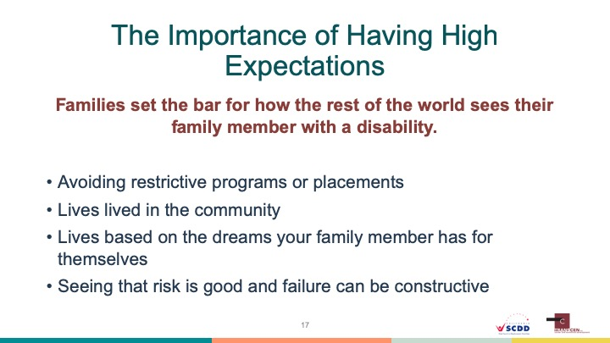
PRESENTER NOTES
Why is it important for families to have and show high expectations for what their family member with a significant disability will achieve in life? For starters, families tend to set the bar for how the rest of the world sees their loved one. If families express doubt that work is possible, that may be what others will believe as well. But if families convey that they expect their family member with a disability to do what all adults are expected to do, then everyone is clear on the goal.
High expectations are also important because it may lead to avoiding unnecessarily restrictive program options like sheltered work or day programs. These programs in of themselves are not “bad”, but they are not an appropriate option for a person who can work in the community. Youth who have a high expectation set for them also may live lives as connected members of their community, live lives based on their own dreams and goals, and live lives where risk and failure are not seen as catastrophic, but opportunities for growth.

Slide 18
THE BALANCING ACT
PRESENTER NOTES
It is important to acknowledge the balancing act we are asking of parents. The reality is that they are expected reconcile the fact that their child has a significant disability with the belief that the child can achieve great things in employment and other areas. This is often challenging when education and service systems put such an emphasis on severity of a disability and less focus on finding a person’s natural talents and skills. In the end families are the keeper of the vision that employment is possible and must balance keeping that vision with the impact of their family member’s disability.

Slide 19
PATIENCE IS THE KEY
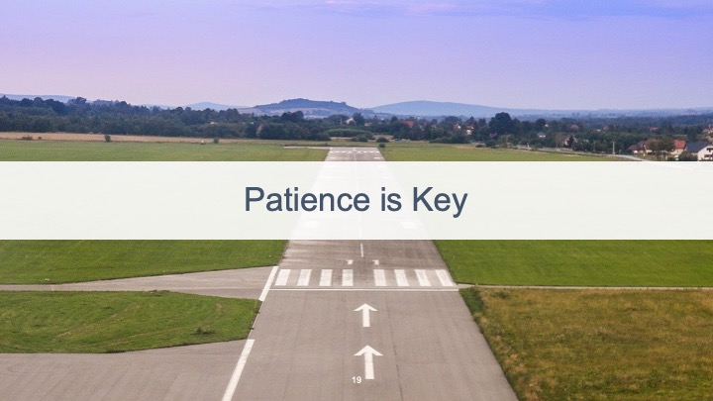
PRESENTER NOTES
Our society has certain artificially created milestones that it expects young people to achieve as they move into adulthood. For example, it is expected that a person will graduate high school around age 18, go to college or get job training, find a job in their chosen field, start a family, and so on. Families of youth with disabilities may feel disappointment if their son or daughter does not meet milestones when same-age peers do.
But we know that different people “take off” at different times, and that’s OK. Some youth may need a longer runway, or take an extended time to mature and develop skills to work and live in the community (with or without supports). Families are encouraged not to worry about artificial deadlines for achievement, but rather to be patient and celebrate the little successes along the way.

Slide 20
WHAT IS SUCCESS?
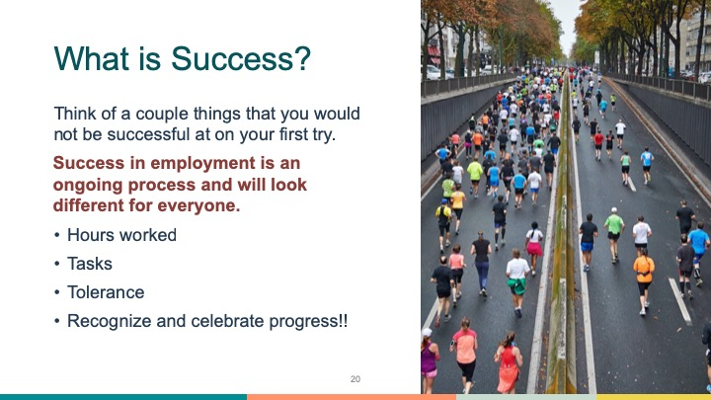
PRESENTER NOTES
Ask attendees to think of a couple things that they would likely not be successful at on their first try. Have a couple people tell the group what they thought. Possible answers might include finishing a marathon, quitting sweets for a month, or speaking a new language.
Now let’s consider the idea of “success” as it relates to youth with significant disabilities and employment. First off, success will look differently for every individual. For one person success might be being able to take public transportation to work by themselves. For another person success might be working 5 hours a week or learning to fold towels. Families know their family members better than anyone else, and will know when their loved one is doing their best and demonstrating new skills. They should view success based on seeing growth in their family member and not based on what everyone else can do.

Slide 21
WORKSHEET QUESTION 2
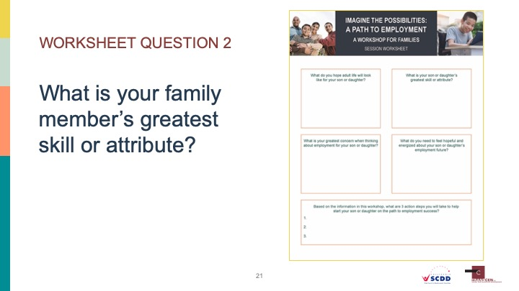
PRESENTER NOTES
What is your family member’s greatest skill or attribute?
Instruct attendees to take a moment to write down in the corresponding box on the worksheet what they feel their family member’s greatest skill or attribute is. Invite 2-3 attendees to share what they wrote. Point out that everybody has skills and talents. The secret is to match a person’s skills and talents with traits that employers are looking for. The next slide goes over a tool to help do just that.

Slide 22
HELPFUL TOOL: POSITIVE PERSONAL PROFILE
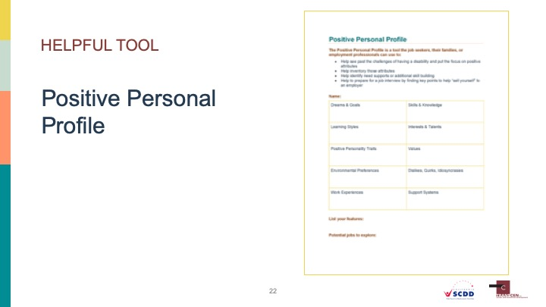
PRESENTER NOTES
The Positive Personal Profile is a tool developed by TransCen Inc. to help identify skills, strengths, dreams, and support systems for job seekers with significant disabilities. It is designed to be filed out by employment professionals, but can also be used by families who wish to pinpoint their family member’s “features”. Features are those things that a person has that employers are looking for. Presenters may wish to spend a little time walking people through the tool, but more likely it would be done independently by families. Make sure to hand out the Positive Personal Profile form at the beginning of the session of at this time.
For families, it may be easy to get stuck focusing on what their youth cannot do, and they forget to look for all the wonderful things their youth can do. The field of disability employment is beginning to see value in finding a person’s positive traits and its relationship to finding a good job match. Focusing on the negative leads to employment decisions based on what a person can’t do. Finding the positive leads to employment decisions based on skills and choice.
One tool available to help families see their family member with a disability in a new way is called the Positive Personal Profile (PPP). The PPP is a simple document that identifies a person’s positive traits. It should be completed with input from families, the youth themselves, teachers, or anybody who knows the youth well. It should also be shared with vocational rehabilitation staff or work experience staff at the schools. Let’s review what each box is asking for:
Dreams and Goals: What does the youth want their life to look like? Answers don’t have to be employment related or “realistic”. We want to know what they hope for so we can begin setting solid goals to work towards.
Skills and Knowledge: Does the youth have real skills in any particular area? Good with computers? Speak another language? Can cook? Knows about restaurants because the family owns one? We are looking for specific things we can market to an employer.
Learning Style: How does the youth best learn new tasks? By watching? By doing? By hearing? This is important information since they will need to learn new skills on the job.
Interests and Talents: What is the youth passionate about? How does the youth like to spend their time? Do they have any fun talents? You may not think these have anything to do with being employed, but they might.
Positive Personality Traits: Is the youth friendly, creative, thoughtful, or energetic? Do they love to learn new things or are known for always lending a hand when needed? These are traits employers are looking for!
Values: A person’s values can be a predictor of what type of job they would enjoy doing. For example, if a person values helping others, then a job at a food shelf or in a hospital might work. If they value taking care of the environment or being outdoors, then maybe an outdoor recreation program or nature center would be a good fit.
Environmental Preferences: We all have a preference in terms of the environment in which we like to work. Some of us prefer to work outside, while others enjoy an office setting. Some youth may need a quiet environment while others may like a fast pace workplace.
Dislikes, Quirks, and Idiosyncrasies: To find a good job match you need to know a person through and through. What are the deal breakers for the youth? Do they dislike florescent lights or strange smells? Do they have a strong interest specific things that may cause a distraction on the job? Do they have fears that people should be aware of? It all gets listed here.
Work Experiences: Remember when we talked about how important work experiences are? This is where they get listed. Did the youth ever baby sit or volunteer in the community? Did they ever have a paid job or help at their parent’s business?
Support Systems: Does the youth already have a county social worker or a vocational rehabilitation counselor? Do they get waivered services? Is the family supportive and able to help with things like transportation?
Features: Once all of the boxes are filled out above, the next step is to pull out the youth’s features- or the things they bring to the table that employers are looking for. This is where we begin painting a picture of the youth for a resume or interview. For example, after filling out the PPP you might discover a youth’s features to be computer skills, likes to learn new things, has an interest in cars and semi-trucks, and has had past work experience volunteering at the library.
Jobs to Explore: Based on the features identified above, what are some jobs that might be a good fit for the youth? For example, the young person described above might want to look into working at a car dealership or trucking company doing computer inventory. It is important to identify potential jobs because that leads to action.
RELATED RESOURCE
Blank Positive Personal Profile form.

Slide 23
BUILDING A VISION STATEMENT
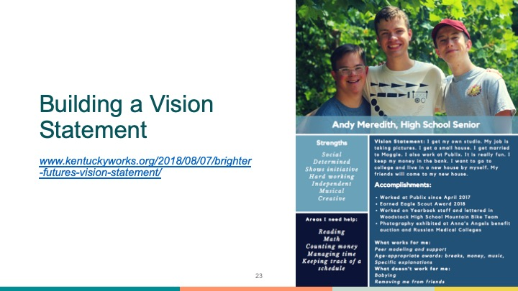
PRESENTER NOTES
Throughout this presentation we have tried to stress the importance of giving youth with disabilities a voice in what they want their adult lives to look like. Living a dignified life includes being able to determine where you live, where you work, and who you spend time with. One way to do this is to help youth develop a vision statement for themselves. The slide provides an example of a vision statement from Andy Meredith from Georgia. He used a template found online to put together information on what he wanted (and didn’t want) his life to look like. You will notice that he includes what type of job he wants, where he wants to live, his strengths, accomplishments and areas he needs help with. He put this together himself with input from family and teachers.
A vision statement like this can be used in many ways. It can act as the map or rulebook for anything that happens on behalf of the youth. It can be presented during planning or IEP meetings to make sure the youth’s voice is heard. It also can be modified as priorities and goals change (just like they tend to do for all of us).
RELATED RESOURCE
Vision statement template can be found at: https://hdi.uky.edu/employment-checklists (Scroll down to “Vision Statement Template”

Slide 24
PREPARING FOR EMPLOYMENT SUCCESS
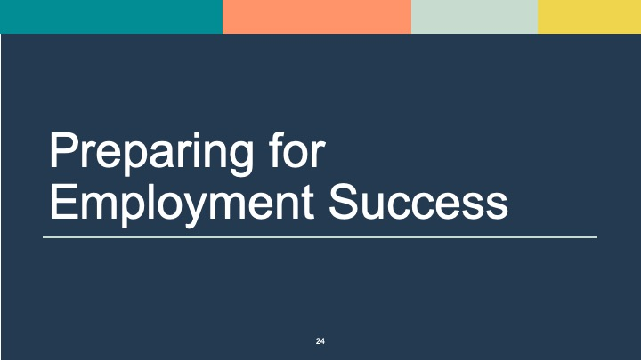
PRESENTER NOTES
This is section break slide indicating a shift to discussing ways families can help youth prepare for employment. The idea is to encourage families to take responsibility for helping their family member with a disability build skills and explore possible jobs.
All of us needed to learn things so we could be good employees or business owners - we were not born with those skills. For many of us our parents had expectations about social behavior and responsibilities around the house. We used what we learned in the work world. For example, think about how you learned to greet people appropriately or to take responsibility for tasks you are assigned. Families can help their youth with disabilities prepare for working, and that is what the next section will focus on.

Slide 25
THE POWER OF WORK EXPERIENCES
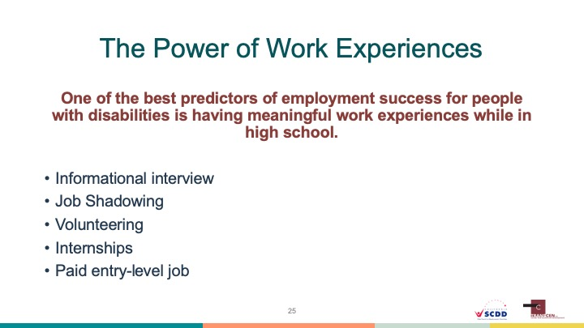
PRESENTER NOTES
One of the strongest predictors of employment success for adults with disabilities is having meaningful work experiences while in high school. Ideally the experience would be a paid job, but those aren’t always available. The key word is “meaningful”. A meaningful work experience is one that is in the community, doing or learning about actual work that is required in a specific job, and that is related to what a youth is interested in. Here are the various types of work experiences youth can engage in:
Informational Interview: A youth interviews a person who is in the job field they are interested in exploring. For example, a young person speaking to a nurse about what they do and the education needed.
Job Shadowing: A youth visits, or shadows a person doing a job they are interested in. For example, a young person could shadow a shipping manager in a warehouse if that is the type of job they are interested in.
Volunteering: Gaining work experience by providing time and energy for an organization that needs it. Most often associated with helping people in some way. Volunteering can look good on a resume and be great experiences for youth. However, families need to know that volunteering is not a substitute for paid employment. Volunteer opportunities should be time limited, or done in addition to a paid job.
Internships: Internships are structured experiences where a person essentially works at a business (either paid or not) for a set time to gain knowledge and show skills. It is common for summer youth employment programs to feature internships for older students.
Paid Entry-Level Job: Of course the best work experience is actually getting paid to work. Don’t assume that because a person has a significant disability that they can seek employment like everyone else. It is not always necessary to wait for employment services to help find jobs.

Slide 26
USING YOUR NETWORKS
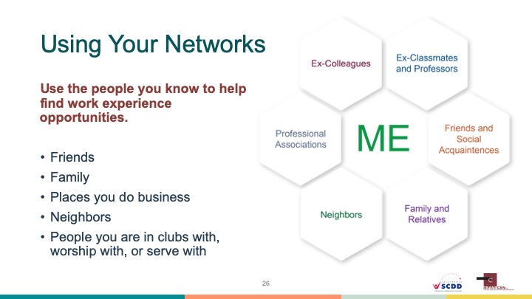
PRESENTER NOTES
Families may feel intimidated by the prospect of helping their family member find work experiences. One effective way is to use personal networks to find opportunities for youth to work or learn about careers they are interested in. The term “personal network” may sound formal, but the fact is that everyone has a network of people they know. They include friends, neighbors, co-workers, places you do business, and extended family. All of these people have networks of their own - people who may know somebody who works in a field a youth is interested in.
Consider this example: A youth is interested in working with animals, and maybe even becoming a veterinarian someday. The youth’s mom doesn’t personally know anybody who works in that field so she asked her book club friends if they had any contacts. Ends up a friend’s brother in-law is a veterinarian. He was contacted and agreed to an informational interview. The interview went so well that he invited the youth to shadow him on the job for a day. The experience was so energizing that the youth now is building skills to become a vet tech, and someday would like to be a veterinarian himself.

Slide 27
BUILDING RESPONSIBILITIES
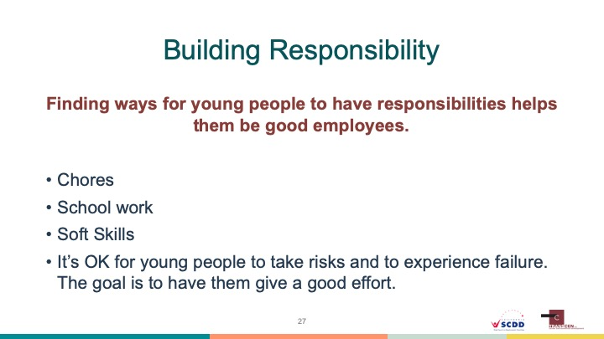
PRESENTER NOTES
A big part of preparing for employment is building skills in youth so they understand what is expected of an employee and can show responsibility and motivation on the job. Building responsibility may seem like a difficult task for youth with high support needs, but it simply implies that a youth work hard and be expected to do the best they can. Families may be apprehensive to hold their loved one accountable for their effort and behavior, but it is an important part of building work skills. Youth should be assigned chores in the home and expected to complete assigned school work. The home is the perfect place for youth to practice “soft skills” (the interpersonal skills we all use at work and in life) such as taking responsibility and maintaining personal appearance. Finally, part of learning responsibility is trying new things and handling failure.

Slide 28
GETTING INVOLVED
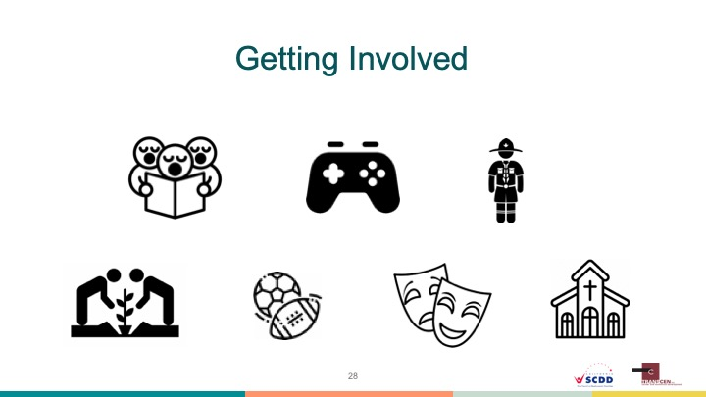
PRESENTER NOTES
Another way for youth to build “transferrable skills” (real life skills that transfer to an employment setting) is to get involved in school-based extra-curricular or community-based activities. To families, it may seem that these types of opportunities are not always available to youth with disabilities. However, there are many ways to make activities, sports, and clubs accessible so everyone can gain the benefits of being involved. In addition, participation in activities outside of regular schoolwork shows employers that a person has outside interests and looks great on a resume.
The icons on this slide show the various types of things that youth can be involved in based on their interests and talents. They include choir or a singing group, a club such as those for video gamers, scouting, a community garden, sports, theatre, or faith-based activities.
If time allows presenters can ask attendees if their family members with a disability are currently involved in any activities and what benefit that has brought to them. Presenters could also ask adult attendees to think about activities they enjoyed as students and how they may have helped build work skills used later in life.

Slide 29
SCHOOL AND EMPLOYMENT
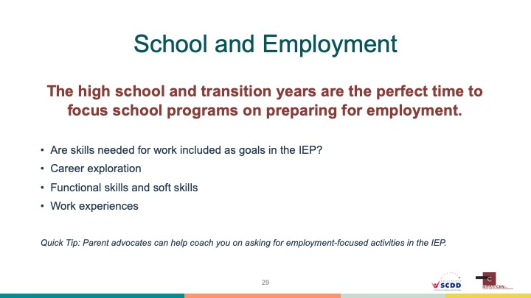
PRESENTER NOTES
Information about leveraging the IEP is included in this workshop only as a way to show families another way to prepare youth for work. Presenters will need to be careful not to let any ensuing discussion drift towards questions of special education laws or process. Presenters can encourage attendees to contact an advocate from a local Parent Training and Information center or another advocacy organization if they have questions about special education.
Families should also be aware that special education programs are charged with helping youth prepare for “transition” - or the movement from school to employment, education or training after high school, and independent living. In recent years, new legislation has put a big focus on interagency collaboration and employment. This means that vocational rehabilitation, county services, and community employment programs can all be part of the effort to prepare youth with disabilities for employment.
The IEP is the driver of programming if a student qualifies for special education services. Once a youth turns 14, the IEP should contain goals related to the transition we talked about. Those goals should address career exploration, building functional work and soft skills (math, technology use, communication, etc.), providing work experiences, and other things a youth needs. Those needs are based on assessments done by the education team. Unfortunately, many youth have very weak transition goals in their IEPs. If parents have questions they should contact a parent advocate.

Slide 30
CONSIDER ALL POSSIBLE SUPPORTS
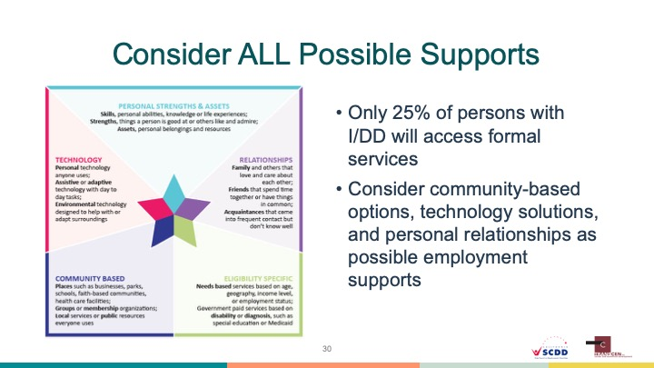
PRESENTER NOTES
This information is intended to help families see that eligibility-based programs are not the only source of employment supports available to a person with a disability. In fact, a relatively small percentage of people with intellectual and developmental disabilities actually access formal services. Families might get discouraged when facing waiting lists or a shortage of employment supports. Considering all possible support options may help families get creative as they consider how to support their loved one towards employment success.
Families of people with high support needs are likely well aware that the availability of “programs” does not meet the need for all who could use support to be successful in employment. In fact, a relatively small percentage of people with intellectual and/or developmental disabilities will ever access formal, eligibility-based services. Some families will find this discouraging and think there are no options for their loved one. However, eligibility-based services are just one option to support people to find and maintain employment.
The graphic on the slide is the “Integrated Supports Star” from Charting the Life Course. It is used as a planning tool for families to help them consider all of the supports an individual has, especially in areas not often thought of. The five areas of the star have spaces to list 1) technology-based supports (such as a smart phone or voice to text software), 2) personal strength and assets (such as ability to problem solve or a special skill in using small engine equipment), 3) relationship-based supports (such as belonging to a faith community or having many relatives in one area), 4) eligibility-based supports (traditional developmental disabilities or vocational rehabilitation services), and 5) community-based supports (such as accessible transportation or a community college). Families are encouraged to map out their family member’s range of supports and plan for how they can be used to help explore careers and be successful in employment.
RELATED RESOURCE
The Charting the Life Course tools from the University of Missouri Kansas City are an intuitive and visual set of person planning tools and concepts that can be used to help families plan for a “good life” for their family member with a disability. The Integrated Supports Star on this slide is an example of one of their foundational tools. Presenters are encouraged to explore all of their materials and use them as handouts. https://www.lifecoursetools.com
Slide 31
DISCUSSING YOUR CONCERNS
PRESENTER NOTES
This is section break slide indicating a shift to acknowledging the concerns families have about exploring paid, competitive employment in the community. Presenters again need to facilitate any discussion effectively, staying away from judgement or long discussions about benefits.
We now want to take some time to acknowledge that families have concerns about their youth being employed in the community. Many times these concerns are valid, while other times they are rooted in misinformation or myths about people with disabilities.

Slide 32
HAVING QUESTIONS OR CONCERNS IS NORMAL
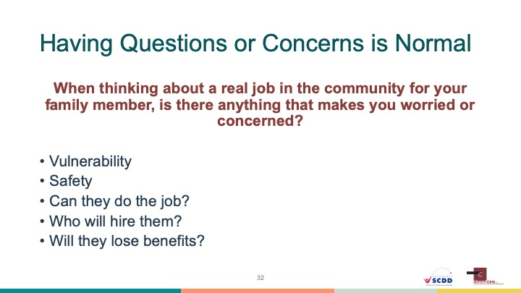
PRESENTER NOTES
Families of youth with high support needs may have serious questions and concerns about their loved one being able to work in the community. Without acknowledging those concerns attendees may not feel as connected to the information being presented. It is important that presenters discuss having concerns in a respectful, non-judgmental way. Stress that nobody is asking them to put their loved one in unsafe situations or to do anything they are not comfortable with. Add that there are people with disabilities working everywhere in our communities and the goal is to find the right job and the right supports so a person can be successful.
This slide begins with a key question for families and caregivers: When thinking about a real job in the community for your family member, is there anything that makes you feel worried or concerned? Let’s face it, the prospect of a person with significant disabilities working independently (with or without supports) can be scary for families. Employment brings many concerns over vulnerability, safety, and questions about a person’s ability to do the work. Will a business hire and respect them? How will their Social Security benefits be impacted? How will they get to and from the job?
Having these questions and concerns are completely normal and valid. Families should not feel bad for having them. However, we know that people with all types of disabilities are currently working in real jobs in their communities. They are valued employees and are gaining all of the benefits of earning and being connected to something meaningful outside of their homes. Families are encouraged to share their questions and concerns about employment with school staff and employment professionals. Doing so begins a process of assessing needed skills, including safety, and identifying possible supports that will allow for employment success. Not expressing concerns may lead to families making decisions about employment that do not allow their loved one to reach the goals and maximize their potential.
Slide 33
WORKSHEET QUESTION 3
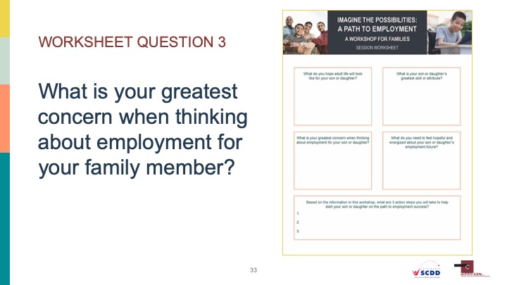
PRESENTER NOTES
What is your greatest concern when thinking about employment for your family member?
Instruct attendees to take a moment to write down in the corresponding box on the worksheet one or two of their greatest concerns when thinking about the prospect of their family member being employed in the community. There is nothing wrong with a parent having concerns over vulnerability or fitting into the workplace. However, it is important that families recognize the many benefits of being employed in the community and show a willingness to address the barriers and issues that are concerns. In other words, concerns should not mean employment is not seen as an option by families. If time allows, invite a few attendees to share their concerns.

Slide 34
MYTHS ABOUT EMPLOYMENT
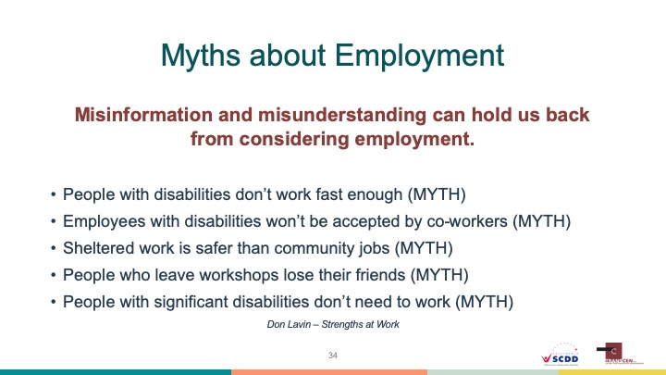
PRESENTER NOTES
The following list of employment myths was originally provided by Don Lavin, consultant/owner of Strengths at Work.
When considering employment in the community we want to make sure families have accurate information so they can make informed decisions. Unfortunately, families can get information that is inaccurate, or based on old beliefs about what people with disabilities can do. These “myths” can hold families back from seeing possibilities and helping their youth reach their goals.
People with disabilities don’t work fast enough: The ability to do a task quickly is required for many jobs, but not all of them. It is becoming common practice to find customized jobs for people that allow them to focus on what they do well.
Employees with disabilities won’t be accepted by co-workers: Disability touches almost everyone in one way or another. People may experience a disability themselves or have a relative with a disability. The point is that most people are comfortable with working alongside all types of co-workers.
Sheltered work is safer than community jobs: Families sometimes have the idea that it is safer for their family member with a disability to be around other people with disabilities in a controlled environment. Sadly, safety within a sheltered workshop or day program is no guarantee either. Through the use of natural supports (co-workers supporting the employee with a disability) a person can be just as safe in a job in the community.
People who leave workshops lose their friends: With the advent of social media it is easier for people to stay connected. In fact, people can expend their friend base by having a job in the community while keeping in touch with old friends from the workshop or day program.
People with significant disabilities don’t need to work: We talked earlier about all of the positive impacts of employment, including a feeling of contribution and accomplishment. Employment is an expectation of adults in our society and the same should hold true for people with significant disabilities. A person’s quality of life is not improved by isolating them and “taking care” of them.
RELATED RESOURCE
KentuckyWorks 6 Myths about Workers with Disabilities Infographic:
https://kentuckyworks.org/2018/03/28/6-myths-about-worker-infographic/

Slide 35
SOCIAL SECURITY BENEFITS: MYTHS AND BENEFITS
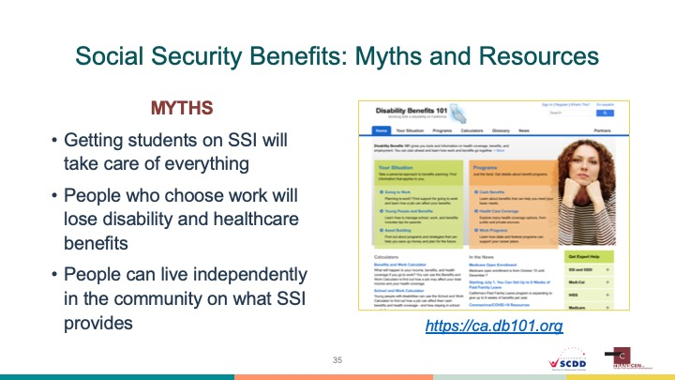
PRESENTER NOTES
In addition to the employment myths listed above (left side of slide), families may also carry some misunderstandings about the impact of Social Security benefits on employment. The following myths are commonly held:
Getting students on SSI will take care of everything: There was a time not too long ago where families were strongly encouraged to get their kids onto Social Security benefits like Supplemental Security Income (SSI). One reason was that SSI was seen as a path to guaranteed income for somebody who cannot work. We now know that 1) many people who can work are afraid to for fear of losing SSI, and 2) being on SSI is not the magic cure providing a lifetime of support. People on SSI live at or below the poverty line. The benefit is simply not enough to live on independently.
People who choose work will lose disability and healthcare benefits: Yes, if a young person chooses paid employment, that will impact the amount of SSI they can receive. However, benefits analysis tend to reveal that working almost always puts a person ahead financially over relying on the SSI benefit amount. In addition, many states have “buy-in” programs that allow a person to keep healthcare benefits while working.
People can live independently in the community on what SSI provides: A recent study showed that the average rent in every state is now larger than the average SSI monthly benefit. A person with a disability simply cannot live independently in the community (factoring in rent, utilities, food, transportation, and recreation) on the SSI benefit alone.
The right side of the slide shows a screen shot of California’s DB101 (Disability Benefits 101) website. This is a statewide resource where beneficiaries of Social Security benefits can get their questions answered about how paid work impacts benefits. Families are encouraged to use this, or other benefits experts, to get clear answers about Social Security and avoid making decisions based on inaccurate information.
RELATED RESOURCE
How to Make SSI Work for You: Simply Said
https://www.pacer.org/transition/video/player.asp?video=103

Slide 36
WORKSHEET QUESTION 4
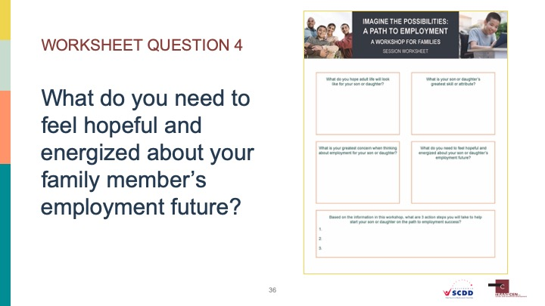
PRESENTER NOTES
What do you need to feel hopeful and energized about your family member’s employment future?
Instruct attendees to take a moment to write down in the corresponding box on the worksheet what they feel they need to help them feel more hopeful and energized about the idea that their family member with a disability can be employed in the community. Do they have major questions that need to be answered? Would they like to know how employment will impact benefits or do they want to speak to other families who have experienced success? One of the main reasons for holding this workshop is to help families feel more hopeful. They should be encouraged to ask for what they need so the process can move forward. If time allows, invite a few attendees to share what they wrote.

Slide 37
ACTION STEPS: GETTING STARTED
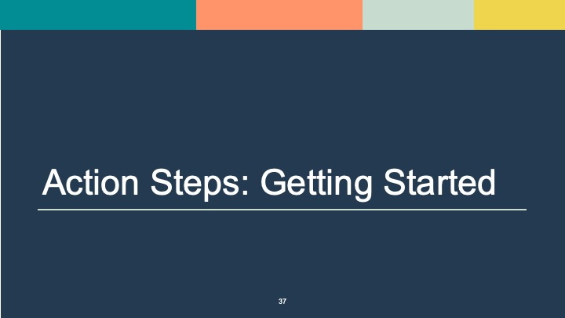
PRESENTER NOTES
This indicates the last section break. We want to have families leave with an idea of what steps they will take to become more comfortable with the idea of employment for their family member with a disability. Section is very short- just the worksheet question slide and takeaways.
We have provided families with a lot of information related to exploring paid employment as an option for their family members. Many families feel overwhelmed after hearing so much information, so it is helpful to have them think about 3 thinks that they will do (action steps) in the next few weeks.

Slide 38
WORKSHEET QUESTION 5
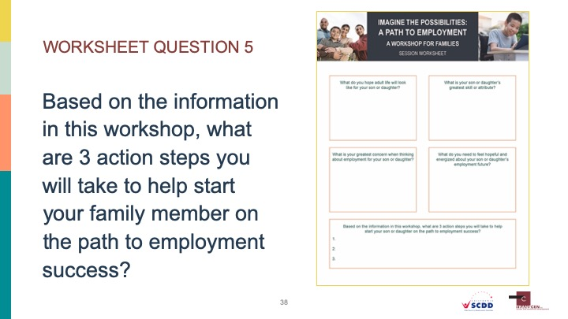
PRESENTER NOTES
Based on the information in this workshop, what are 3 action steps you will take to help start your family member on the path to employment success?
Ask attendees to reflect on the information they have heard and write down 3 action steps that they will take in the next few weeks to help start their family member on the path to employment in the community. If time allows, ask a few attendees to share their action steps. If families are unable to identify specific action steps, they can also write down 3 things they learned during the session.

Slide 39
TAKEAWAYS
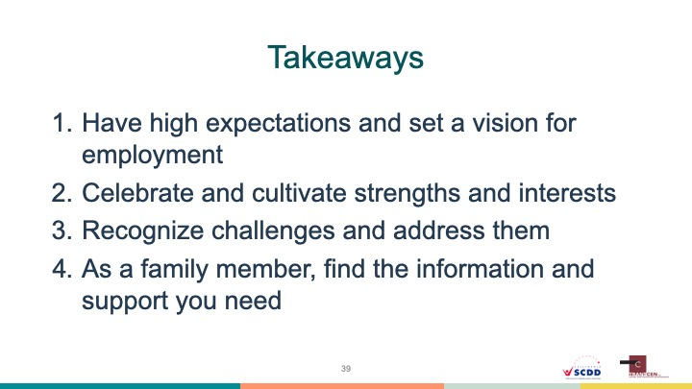
PRESENTER NOTES
This slide is meant to provide a quick summary of the main concepts we hope to have attendees walk away with. It can be gone over quickly.
We hope families and others who attended the workshop found the information useful and inspiring. The intention was to answer some key questions, show success stories and to instill the idea that employment is possible for youth with significant disabilities. We hope we showed how important high expectations are and how valuable it can be to help a young person set a vision for their life that includes employment. We talked about the fact that all people have skills and interests that if grown, can lead to employment. We also encouraged families to recognize challenges and concerns and to address them (or to get supports that address them) before they become permanent barriers. Finally, we asked that families find the information and support they need to get questions answered and to become energized at the prospect of community-based employment.

Slide 40
QUESTIONS AND EVALUATIONS
PRESENTER NOTES
It is encouraged that you use a session evaluation to gauge how useful the material was to attendees. Please ask that attendees turn their evaluations in before leaving. If able, presenters are asked to provide copies of the session evaluations to the California State Council on Developmental Disabilities at bayarea@scdd.ca.gov.
Presenters are asked to leave at least 10 minutes at the end of the presentation for questions. If time does not allow for questions, offer to say after the session ends to speak with families. Remember that no one person or duo of presenters are expected to be experts on all aspect of employment for youth with significant disabilities. Don’t be afraid to tell somebody you don’t know the answer to their question. In those cases offer to take their contact information and tell them you will connect them with a person who can provide an answer.

Slide 41
CONTACT INFORMATION
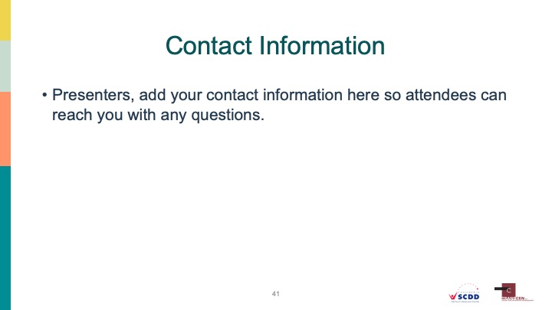
PRESENTER NOTES
Presenters should provide their contact information for attendees. Part of the responsibility of delivering this training will be the willingness to have families contact you with questions and connect them with other resources if necessary.

Slide 42
WHY CONDUCT PARENT TRAINING
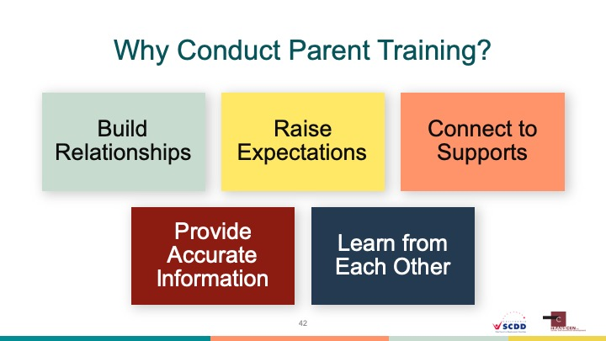

Slide 43
PARENT TRAINING TIPS: TIME AND LOCATION
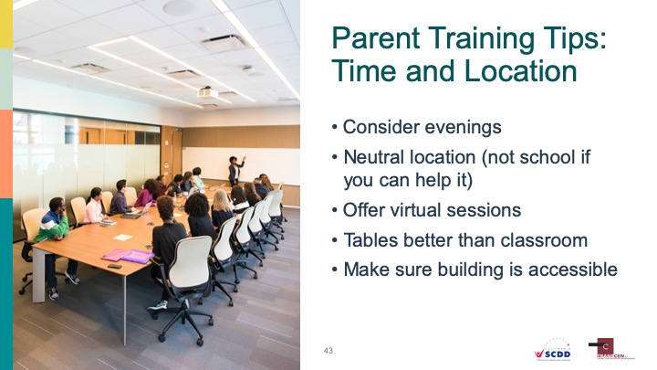

Slide 44
PARENT TRAINING TIPS: PARTNERS AND PROMOTIONS
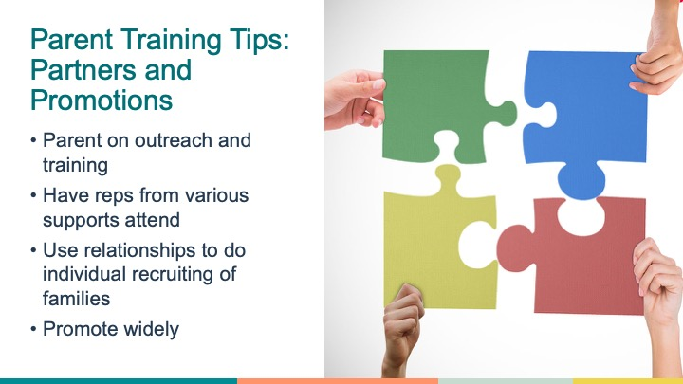

Slide 45
FLYER EXAMPLE
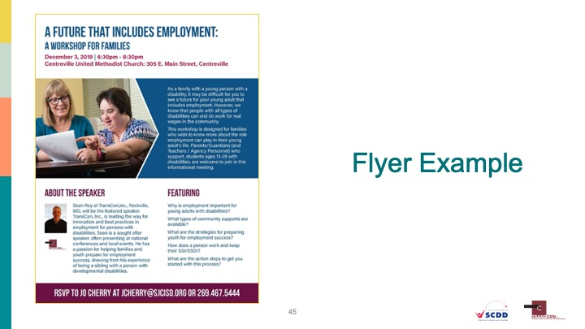

Slide 46
PARENT TRAINING TIPS: PRESENTING EFFECTIVELY
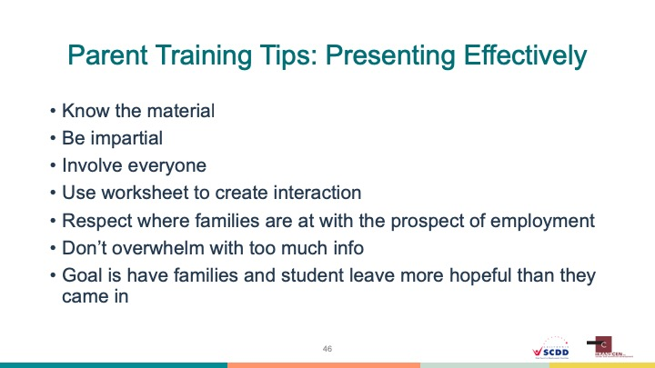

Slide 47
CONTACT INFO
